**User Guide for DISCOMs/ PDs - PRAAPTI Portal**

**(For Recording Dispute on PRAAPTI)**

Procedure for Recording Dispute

## Updation of Dispute on PRAAPTI

The process flow for Disputing invoice on PRAAPTI Portal:

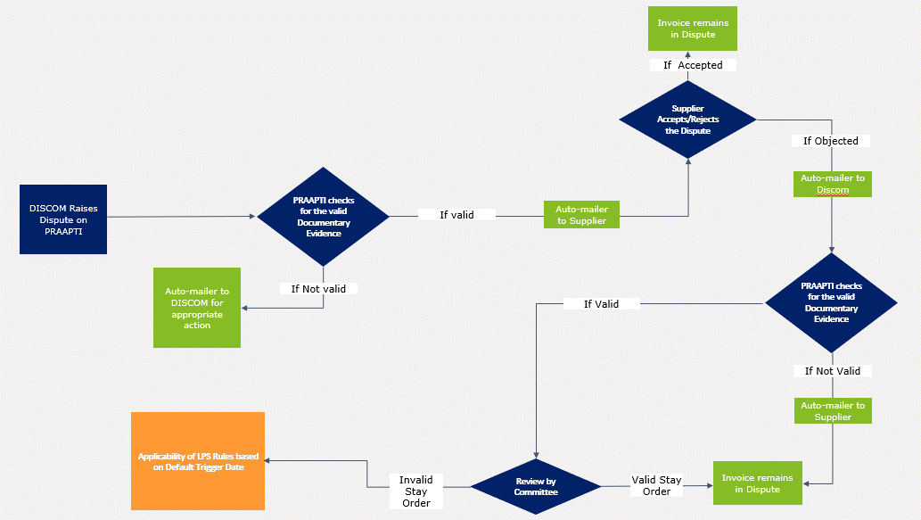

1. Go to invoice list and click the “₹” symbol to update the Dispute

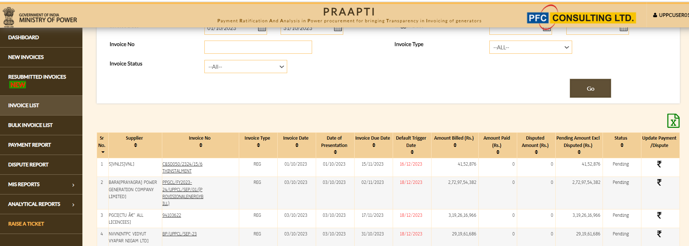

1. Click on the Report Disputed Amount

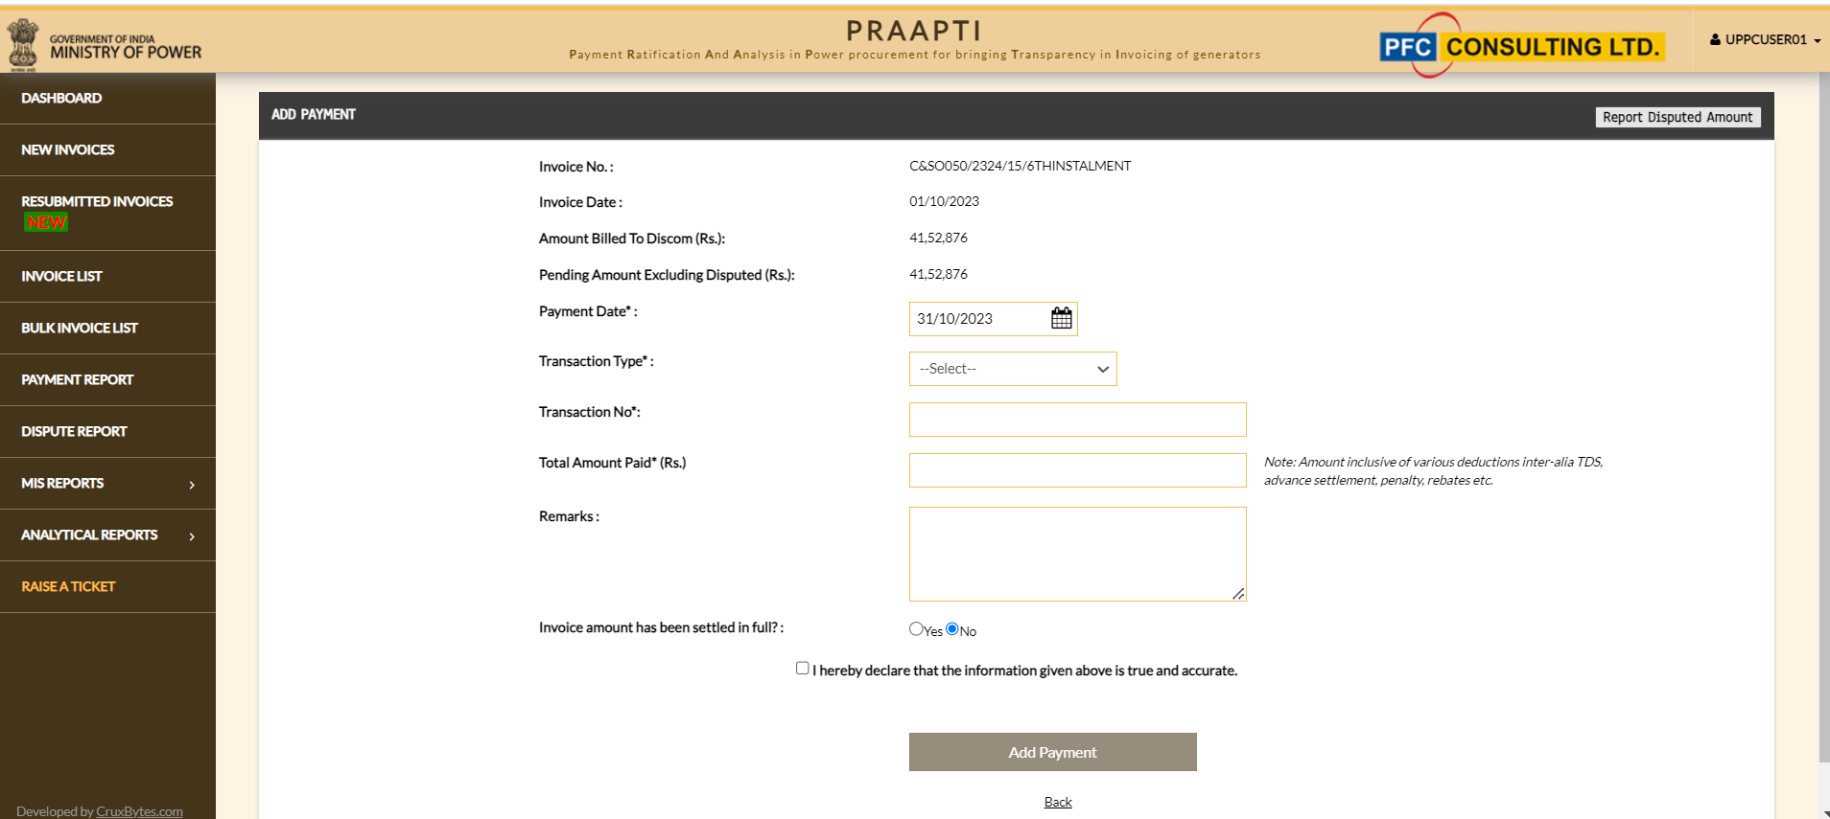

1. Fill the Dispute Details and click on “Update”: Enter the details such as Disputed Amount, Competent Court / Tribunal/ Dispute Resolution Agency, Order Number, Date of Order, Upload copy of a Brief Note (in the format attached in Annexure-A), Upload copy of valid stay order, Authorized personal details etc.

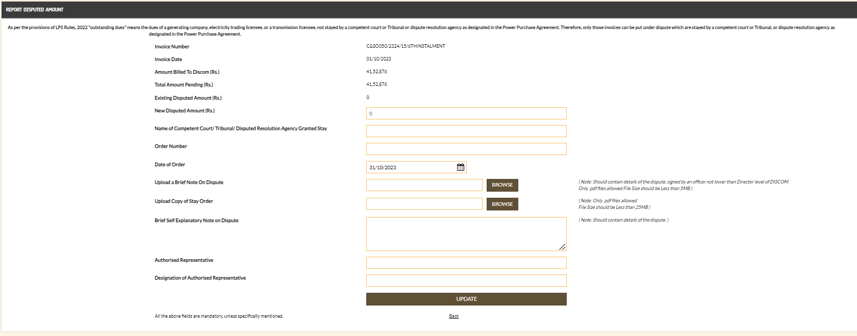

1. Click on “I Agree” and submit to confirm the undertaking

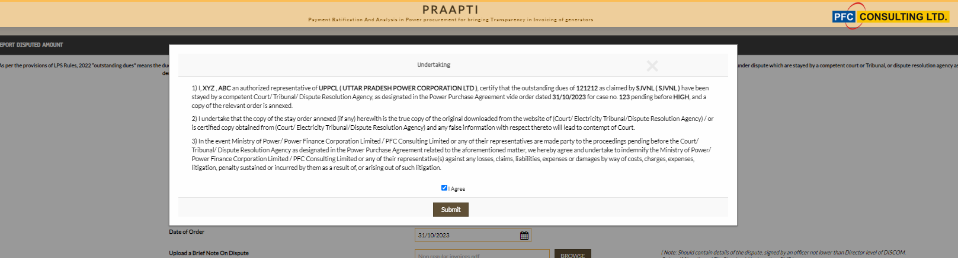

1. Once the Dispute details have been added, the Discom can view the Dispute Details of the invoice and access the further details through Dispute Report

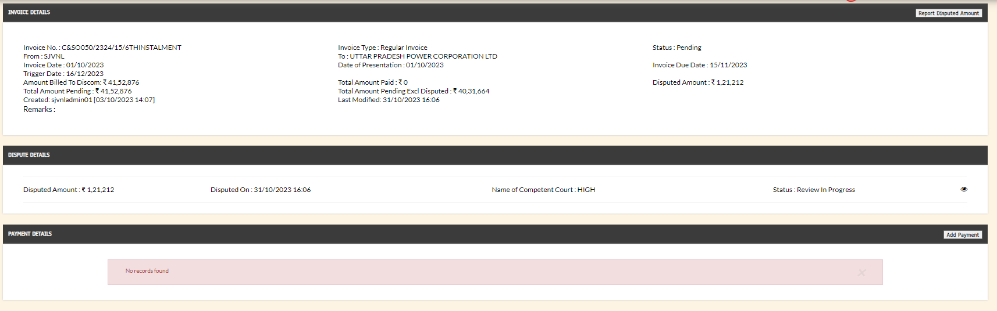

**Contact Us**

**For any technical support/ query, please contact**



Email ID: pfccl.app@cruxbytes.com



Telephone: 9920354533

**For any procedural query, please contact**



Email ID: praapti_pfccl@pfcindia.com



Telephone: 9953147342

**Annexure-A : Format of Brief Note**

Date: __________

|  |  |
| --- | --- |
| Sl. | Particulars |
| 1 | Description of invoice to be disputed:   1. Supplier Name - 2. Invoice No. - 3. Invoice Amount –   *\*Invoice No. and Invoice amount should be strictly as per PRAAPTI Portal*  * *In case multiple invoices to be disputed by Discom for same reason, please attach the list of invoices as sAnnexure to this Note. Annexure to be duly signed by Nodal Officer/ Authorized Representative of Discom.* |
| 2 | Description of relevant orders (Please mention date wise orders applicable for the case):   1. Order No./Order Date/Order Issued by - 2. Order No./Order Date/Order Issued by - 3. Order No./Order Date/Order Issued by -   * *DISCOMs need to necessarily provide and upload valid documentary proof (copy of stay order/orders) on PRAAPTI Portal to substantiate the disputed invoice amount.*  * *DISCOMs are required to include the Order Number, along with the Order Date and the Issuing Authority. These orders should be listed chronologically based on their respective order dates. DISCOMs are also required to highlight the pertinent sections of the orders.* |
| 3 | Reason for disputing the invoice by Discom (Provide details of the proceedings in accordance with the order dates) – Inputs provided by Discom should be brief, self-explanatory and precise   1. …………… 2. …………… |
| 4 | Details of Competent Authority (not lower than the Director level) of Discom for approving the re-return of above-mentioned invoices on PRAAPTI   1. Name - 2. Designation (not lower than the Director level) – 3. Signature – |

Brief Note for disputing invoice on PRAAPTI by [mention Name of Discom]

**Annexure for Brief Note**

*(Applicable in case multiple invoices to be disputed by Discom for same reason)*

|  |  |  |  |
| --- | --- | --- | --- |
| **S. No.** | **Supplier Name** | **Invoice No.** | **Invoice Amount**  **(Rs.)** |
|  |  |  |  |
|  |  |  |  |
|  |  |  |  |
|  |  |  |  |

***Nodal Officer/ Authorized Representative of Discom***

1. Name -
2. Designation –
3. Signature –